Phoenix 1.4 and C Programs Email Enhanced User Manual.

The operation of the Phoenix system and C programs are the same as before any changes except now there is the ability to change certain information regarding the sending of emails.

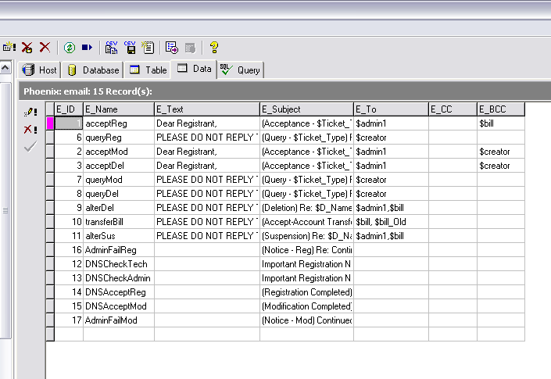
VB Emails
C Emails
Figure 1.0
Here in figure 1.0 we can see the database table used to hold the email information. The various fields are:
- E_ID – this is a unique ID number for each email.
- E_Name – this is a unique name for each email.
- E_Text – this fields holds the body of the email itself.
- E_Subject – this holds the subject for the corresponding email.
- E_To – which holds the TO recipients for the email.
- E_CC – which holds the CC recipients for the email.
- E_BCC – which holds the BCC recipients for the email.

Notes about each:
- E_ID – this should never be edited.
- E_Name - this should never be edited.
- E_Text – this can be edited under certain conditions.
  - The variables start with a $ like $D_Name or $remark.
  - These can be placed any where in the email body.
  - These variable names are case sensitive.
  - The maximum number of variable names are present in each email currently. IE if an email has $D_Name present in it then only $D_Name can be used in it in the future, even though the email text may change around it and other variable names may appear in other emails. This also applies to the E_Subject field.
  - The text is not appearing in the database row for the C programs due to a carriage return at the beginning of the email text.

- E_Subject - this can be edited under certain conditions.
  - The variables start with a $ like $Ticket_Type or $D_Name.
  - These variable names are case sensitive.

- E_To, E_CC, E_BCC - these can be edited under certain conditions for the Phoenix emails only.
  - Any number of email contacts can be entered in any of the address bars. However they must be separated by a comma (,).
  - Entering email values into the E_To, E_CC and E_BCC bars will have no effect on the email as these recipients are static.

Area | Variable | Represents
Text | $D_Name | Domain Name
Text | $remark | Remark after deletion etc
Text | $diff | Difference between dates of Stalled emails etc.
Text | $billNH | When transferring billing contacts the new Bill Nic Handle
Text | $bill_OldNH | When transferring billing contacts the new Bill Nic Handle
Text | $Domain_Holder | Company holding the domain
Subject | $Ticket_Type | Registration, Modification or deletion
Subject | $D_Name | Domain Name
Address | $admin1 | Admin 1 Contact Email Address
Address | $admin2 | Admin 2 Contact Email Address
Address | $creator | Ticket Creator Email Address
Address | $bill | Bill Contact Email Address
Address | $bill_Old | Old Bill Contact Address in transfer email
Address | $tech | Tech Contact Email Address

